Task 5.2: Change the Light Intensity Using GUI
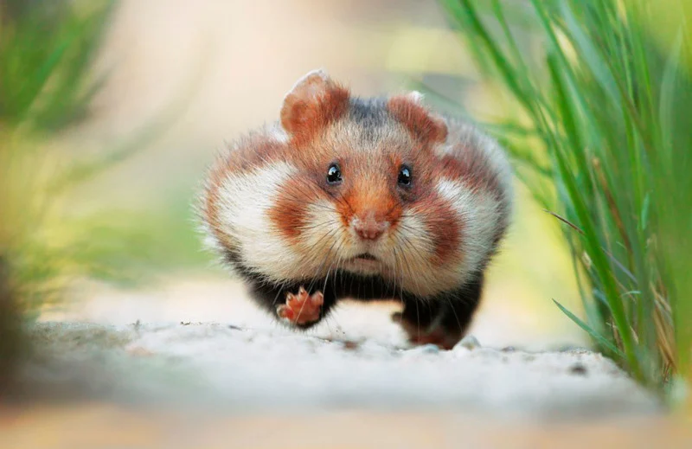

Its very empty here so here’s an absolute unit of a hamster

GitHub link: https://github.com/charlieM044/SIT210/tree/6d4b09818653e0ce30fde23be8b20fab6a631dbd/task%205.2

Video link: https://youtube.com/shorts/L5RNBgPJt3w?feature=share

